Ioannis Chatzis, PhD (1980), Distinguished Professor Emeritus
Department of Chemical Engineering, University of Waterloo, Canada
Abstract
In this talk, I will provide an overview of the petroleum engineering discipline and the areas petroleum engineers and others get employment in the petroleum industry. I will also illustrate some of the key research findings in my career path and provide some visualizations of flow behavior during immiscible and miscible displacements in porous media as seen in video recordings of experiments in glass micromodels.

Interests
My training was in Chemical Engineering at the University of Waterloo for all of my degrees. My research interests over the years included among others the following topic areas:
- Characterization of pore structure and modeling of capillary and transport phenomena in porous media using pore network models of pore structure. Petrophysics and special core analysis.
- Flow visualizations in porous media and 3-D computer reconstruction of pore structure of reservoir samples using stochastic modeling of pore space and petrographic image analysis.
- Enhanced oil recovery (EOR) technologies associated with oil recovery by gravity drainage and by using horizontal wells.
- Heavy oil recovery using the vapour extraction (VAPEX) process with use of horizontal well technologies; steam assisted gravity drainage (SAGD) and Solvent-Aided Hybrid processes for Heavy Oil Recovery.
- Vertical sweep efficiency studies of horizontal wells.
- Environmental engineering technologies for remediation of contaminated aquifers, bioremediation techniques, gravity drainage and supersaturated CO₂ carbonated water injection for recovering the oil phase from contaminated aquifers.
- Microfluidics and visualization of flow phenomena in porous media using pore networks etched on glass (glass micromodels) and interfacial phenomena.

In the above topic areas, involved the training of 17 PhD students and over 30 Master’s degree students that I supervised or co-supervised: 11 of the PhD students I supervised/co-supervised became very successful academics (6 in Canada, 2 in Iran, 1 in Finland, and 2 in Brazil). I have spent teaching Chemical Engineering students for over 32 years at the university of Waterloo. I have also taught Petroleum Engineering Students outside of Canada, namely: 5 years in Kuwait University 2015-2019, 1 year at the Petroleum Institute in 2008 (now part of Khalifa University) in Abu Dhabi, UAE, and 2 years (1980-1982) at the New Mexico Tech, USA.
Biographical Sketch of Professor Ioannis Chatzis
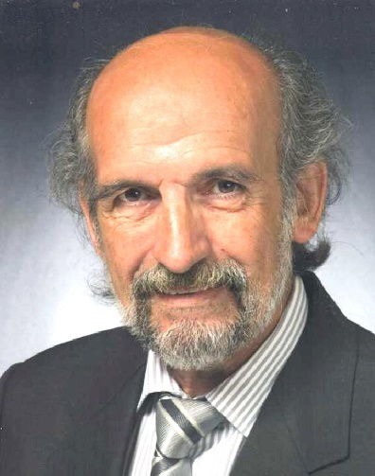 | Distinguished Professor Emeritus  Department of Chemical Engineering  University of Waterloo  Waterloo, Ontario, Canada N2L 3G1  Mobile: 1-519-5038411  E-mail: ichatzis@uwaterloo.ca; jchatzis13@gmail.com  Web pages:  http://scholar.google.ca/citations?hl=en&user=I2N1UYMAAAAJ

PERSONAL

Date and place of Birth: was born in 1949, in the village of KOURKOULOI EVIAS, GREECE

Health: Excellent
Status: Married

Professional Affiliations:
Society of Core Analysts (lifetime member)
Member of the American Chemical Society
Member of the Society of Petroleum Engineers of AIME

EDUCATION
1961 – 1967 High School in Limni - Evias, Greece
1969 - 1974 B.A.Sc. (1974, Chemical Engineering), University of Waterloo, Canada)
1974 - 1976 M.A.Sc. (1976, Chemical Engineering), University of Waterloo, Canada)
1976 - 1979 Ph.D. (1980, Chemical Engineering), University of Waterloo, Canada)

SCHOLARSHIPS/FELLOWSHIPS/AWARDS
National Research Council (NRC) Postgraduate Scholarship (1976, 1977, 1978)
Ontario Graduate Scholarship (1979)
University of Waterloo Scholarships (1977, 1978, 1979)
NSERC University Research Fellowship (1982 - 1992)

Lifetime Technical Achievement Award of
the Society of Core Analysts (SCA) 2006

Prof. Chatzis has 109 papers published in premier journals, has 149 publications in conference proceedings, is co-author of one textbook and has 3 patents. The impact of his Research Contributions is reflected by the following metrics:

- In Google Scholar h- index = 49 with over 8700 citations
- In Scopus h-index = 39 with over 5220 citations
- In Web of Science h-index = 33 with over 3880 citations

